Hi Friends!
Welcome To Ms. Kim and Ms. Mimi's 1st grade Class!

I am thrilled to start my first year teaching at TRCS! I have lots of exciting plans for this year and I look forward to forming our classroom community with you all!

To tell you a little about myself, I was born and raised on the Outer Banks of NC. When we weren't being beach bums my family and I traveled to the mountains to camp, hike, and mountain bike. Being that I fell in love with the mountains at an early age, I decided to attend App State to earn my BA in elementary education. After I graduated I worked in the Ashe County school system and then took time off to stay at home with my son who is now a Kindergartner!

When I am not working I love spending time with my family and friends. I try to be outside whenever possible and especially enjoy hiking, riding bikes, gardening, yoga, playing with my two dogs, swimming and snowboarding. I come from a family full of musicians. I love to play guitar and sing (although I could probably use some practice!) I also enjoy reading, watching movies, and crafting.

I'm looking forward to getting to know all of you. We are going to have a lot of fun this year! I hope you all have a wonderful, restful, exciting, and adventurous summer. I will be in touch in the months to come, but feel free to contact me any time.

See you soon,
Kim Jolly

(252) 423-0398 (call or text)
kimj@tworiverscommunityschool.net
PO Box 1060 Boone, NC 28607

Supplies List

We are going to work hard and have a lot of fun this year, so we will need some supplies. Some of the supplies will be used by your child only for the duration of the school year. We encourage a community of learners so many items will be shared with classmates. I know that school supplies can add up so if you are having trouble paying for any of these items please let me know and we will work it out.

The following are for your child only and will need to be labeled with their name:
1 reusable water bottle (preferably no larger than 16 oz)
3 durable plastic folders with pockets
2 wide ruled composition books
1 set of headphones (not ear buds, unless your child prefers them. I find that headphones are easier)
1 pair of child scissors

The following are to be shared and do not need to be labeled with names:
1 6 pack of glue sticks
1 pack of 4 dry erase markers
1 pack of magic markers
1 2 pack of highlighters
1 pack of construction paper
1 pack of white index cards
1 box of crayons
1 pack of colored pencils
1 pack of #2 pencils (Ticonderoga pencils are AWESOME but any kind will do!)
1 pack of post it notes
1 pack of hand held erasers
2 boxes of tissues
1 bottle of hand sanitizer or hand soap
1 box of zip lock sandwich bags

Wish List:
Amazon Gift Cards (I have big dreams for our classroom and the activities we will do. These will help make those things possible!)

Talk to me :)

Parent Teacher Communication is important to the success of your child and to our classroom. Please complete this form and return it to me to let me know how we can make communication as easy and convenience as possible. I feel like over-communicating is always better than leaving things unsaid, so please never hesitate to come to me with questions, concerns, or information. I look forward to getting to know you all and creating a close classroom environment.

Your Name:________________________________________

Student's Name:____________________________________

Relationship to Student:______________________________

Phone numbers: (cell) ________________________________
(home) _______________________________
(work) _______________________________

Email:____________________________________________

Preferred method(s) of communication circle all that apply:

E-mail phone call text mail other:__________

Please list any forms of communication that don't work well for you: _______________

__________________________________________________________________

My contact info:
cell phone: 252-423-0398
email: kimj@tworiverscommunityschool.net
PO Box 1069 Boone, NC 28607
I also have a mailbox in the main office of TRCS

Growth Mindset

There are ways you can help your child grow into a person who loves to learn, challenge themselves, and be the best they can be! Helping instill a growth mindset in your children will help them tremendously not only in school but for the rest of their lives!

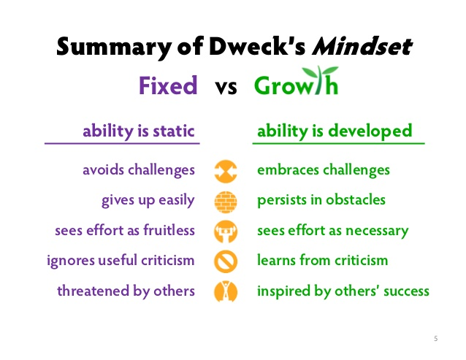

So how do we develop a growth mindset in our children? Praise is more encouraging than criticism but there is more to it than that. Try using a “praise make-over” to emphasize the value of struggle, hard work, and learning from failures and successes.

Instead of saying.... | Try saying....
You're so smart! | You worked really hard, and it shows!
You are so good at this! | I can tell you put a lot of effort into this!
This looks good! | You must have spent a lot of time on your work!
It makes me happy when you do well! | It makes me happy when I see how much you have grown and how hard you are working!
Great Job! | I can tell you really focused on accomplishing this task!

Now what do we do if our children are struggling? They need honest feedback, empathy, and guidance. Think back to a time when you felt like giving up on something. The struggle is REAL! It is important to help remind our children that struggle is a good thing. When our muscles are sore it means they are getting stronger. It is the same with our brains, only instead of hurting physically like a burning muscle it hurts emotionally.

When they say.... | Re-frame their thinking by saying...
This is too hard! | This feeling of something being hard means you are growing.
I can't do this! | I know it can be frustrating when you are still learning how to do something.
I am not good at this! | You are still working to master this skill.
I don't want to try anymore! | Let's break this down into smaller, more manageable steps. I am here to help you.
I don't get it! | Tell me what part of this you are struggling with. What strategy can we try?

DON'T FORGET to point out their success after a struggle. “Remember when you thought you couldn't _______? That was really hard. You felt like you might want to give up. I am so proud of you for trying so hard so you could get better! How does it feel to know that YOU succeeded?”

